Funke’s Cloud Exam
- Create a new project
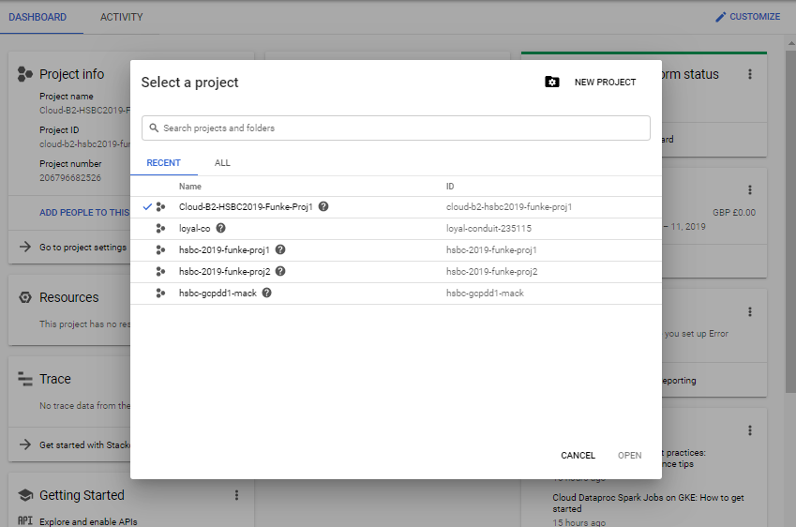
[Cloud-B2-HSBC2019-Funke-Proj1]

- Create a project named [Cloud_ B_HSBC2019_ -Proj1] and grant editor role granted for the user, Also, additionally grant project Billing Manager Role, Compute Admin Role, IAM admin Role and get started with the below activities [5]

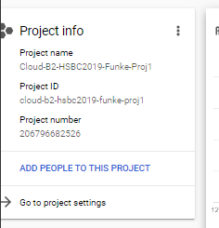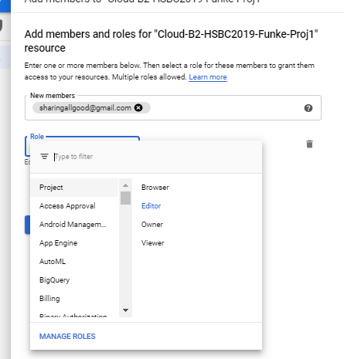
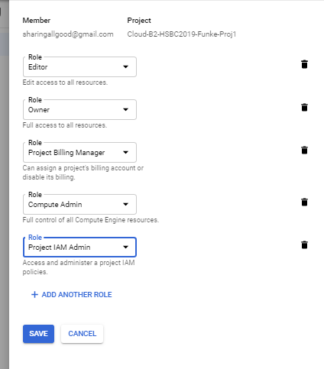
STEPS
- Create an instance [Cloud_ B_HSBC2019_ -inst1] of Debian Linux instance with apache installed. – [3]
- Under Compute Engine
- 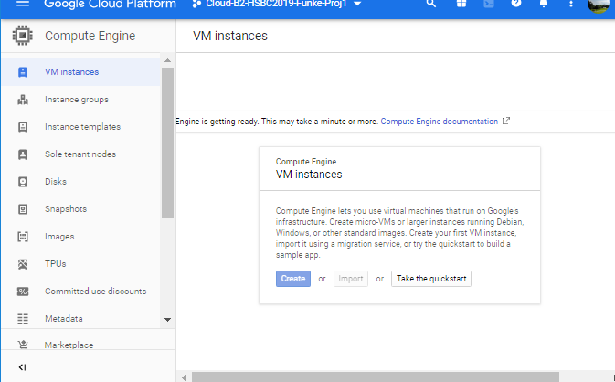
- cloud-b2-hsbc2019-funke-inst1
- 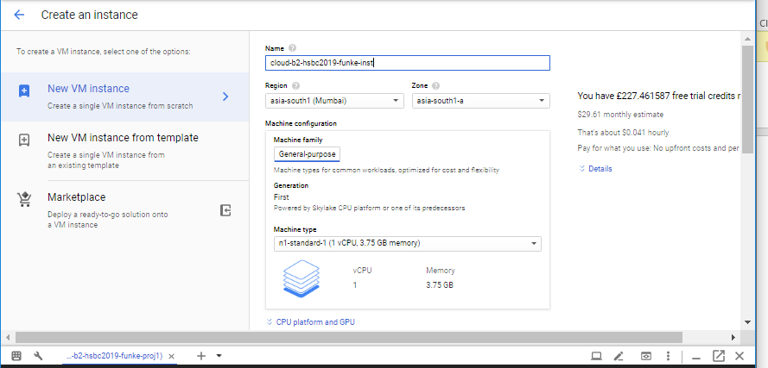
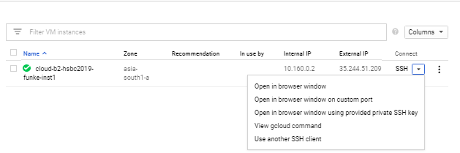

sudo su –
apt-get update
apt-get install apache2 -y
service apache2 start
service apache2 status
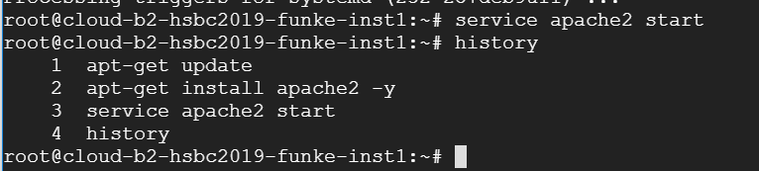
- (all steps until (service apache2 status))
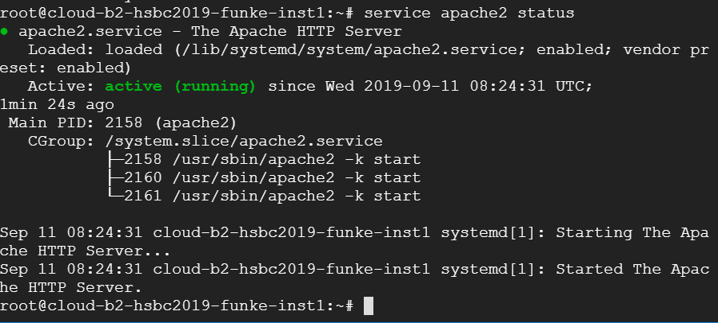
- Run: service apache2 status

- Create a custom image of this instance with the name [Cloud_ B_HSBC2019_ -img1] [1]
Name: [cloud-b2-hsbc2019-img1]
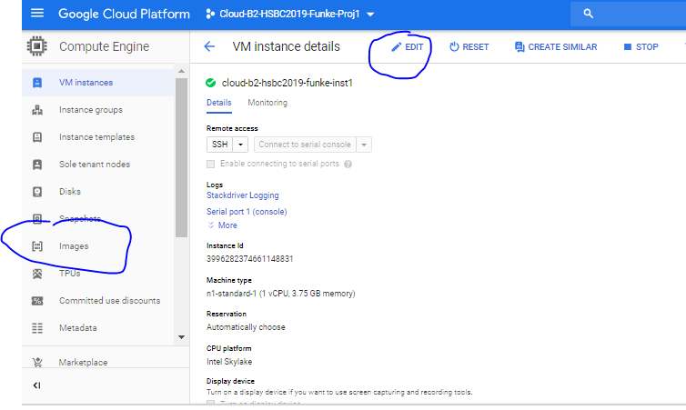
(Associate the image to the instance)
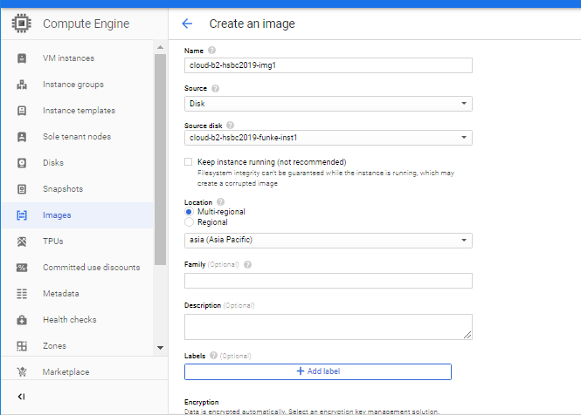

(stop the instance…
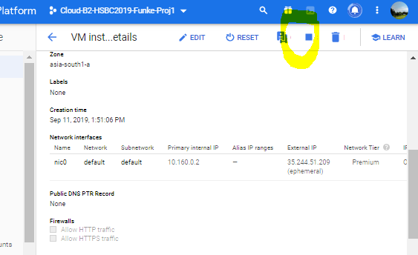

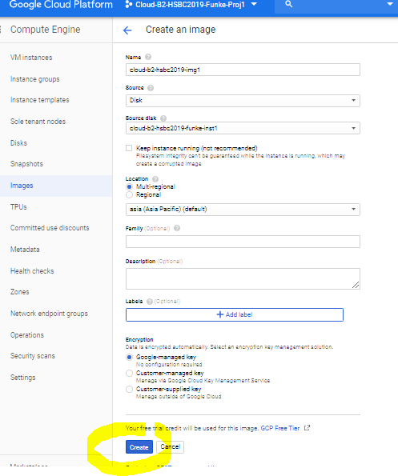
(I did not select the option to keep the instance running!)

- Now, Create an instance template with the name [Cloud_ B_HSBC2019_ -template1] [1]
- Under compute engine.
- cloud-b2-hsbc2019-template1
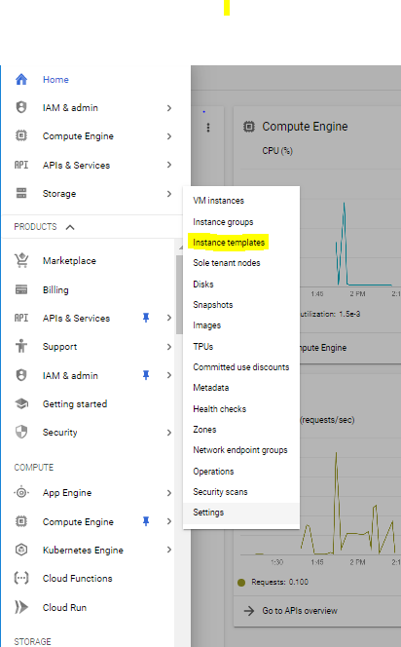
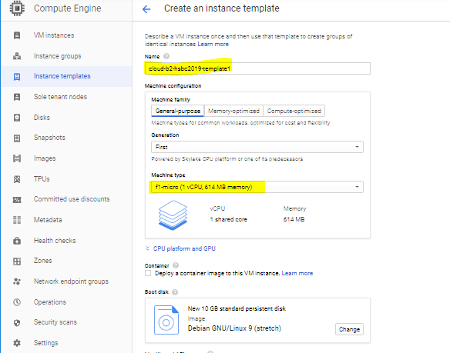
(change name, and optimize the machine type) (f1-micro)

- Make use of this instance to create 2 instance groups in two different regions [Cloud_ B_HSBC2019_ -mig_region [10]
cloud-b2-hsbc2019-mig-region

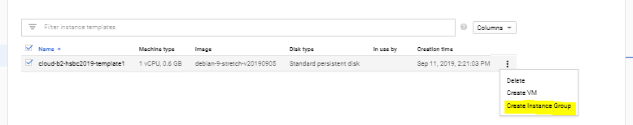
Create first
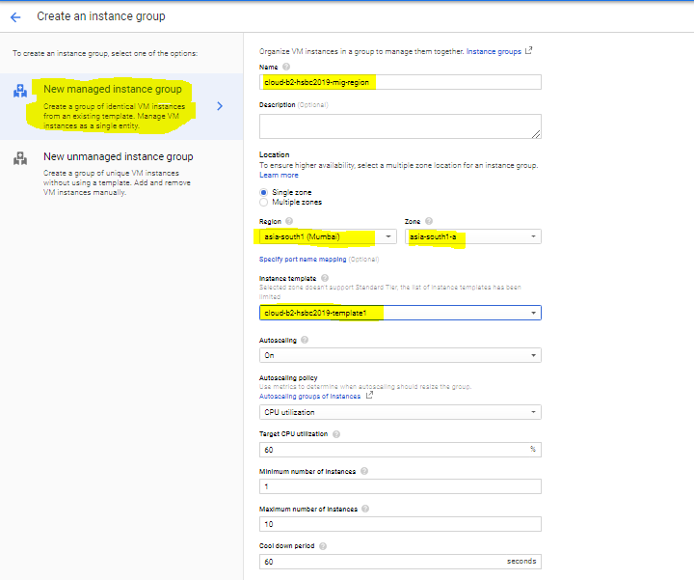

Create second
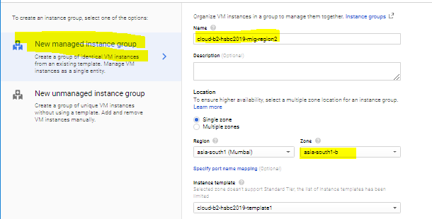

- Connect this instance group to a Load balancer named [Cloud_ B_HSBC2019_ -lb with
cloud-b2-hsbc2019-lb

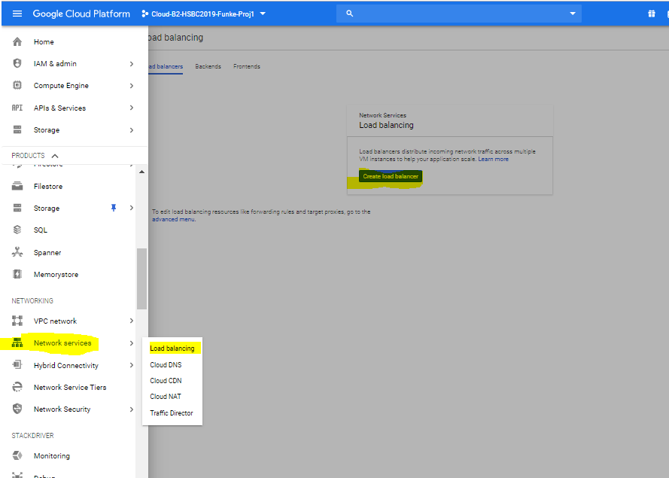
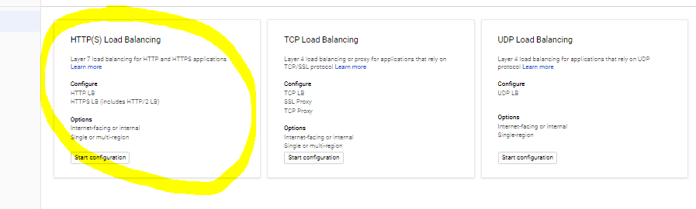
Select HTTPS as it’s most reliable and secure.
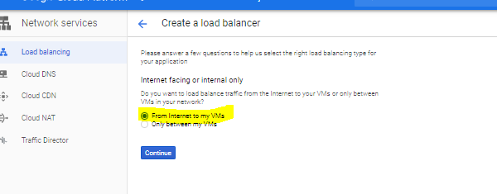
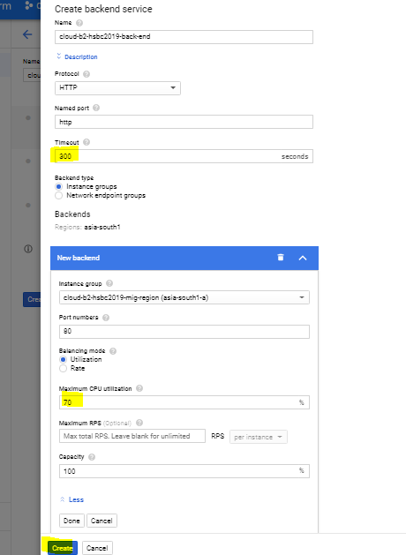
- Minimum instance of Auto scaling of 1 instance and maximum number of instance is 3 [ 3]
- CPU utilization as 70% [ 2]
- Health check with cool down period of 300 seconds. [5]
- Capture the snapshots of all the above steps and copy it in a word document and save it as [Cloud_ B_HSBC2019_ ]

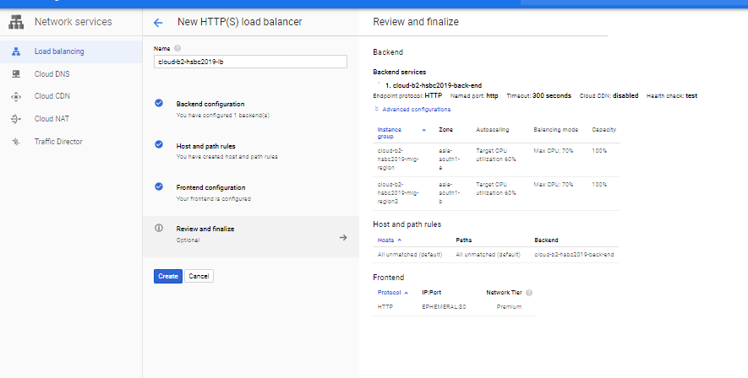
COMPLETE!

- Create a custom network [Cloud_ B_HSBC2019_ -nw with one subnet. [10]
cloud-b2-hsbc2019-nw 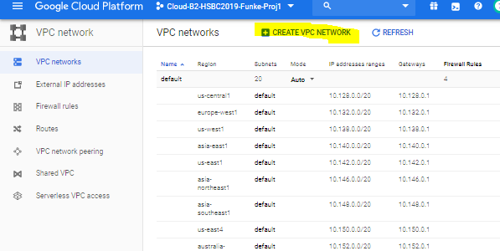
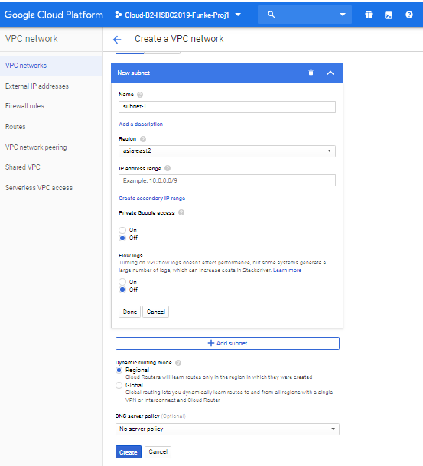
- Create an instance to test the load balancer. [5]

3. SSH into the instance and execute following command sudo su – apt-get install apache2-utils -y ab –n 100000 –c 1000 http:///

4. Navigate to Monitoring tab in load balancing section and capture the screenshot,

5. Capture the snapshots of the above steps and copy it in a word document and save it as [Cloud_ B_HSBC2019_ ] [5]
Part 2) Networking.

